United Dioceses of Dublin and Glendalough

1216 2016

800 Years Together

“Camino de Glendalough”
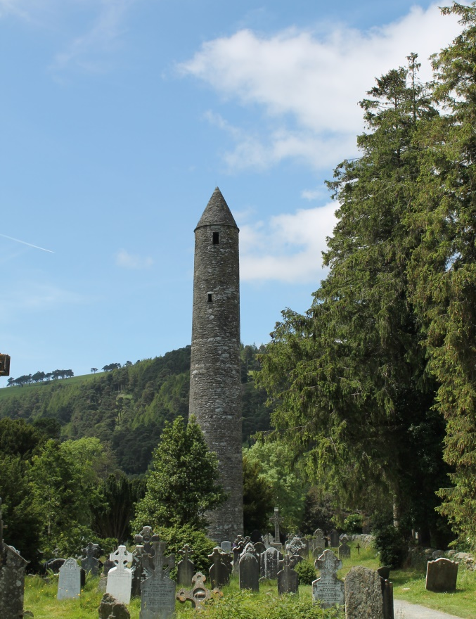

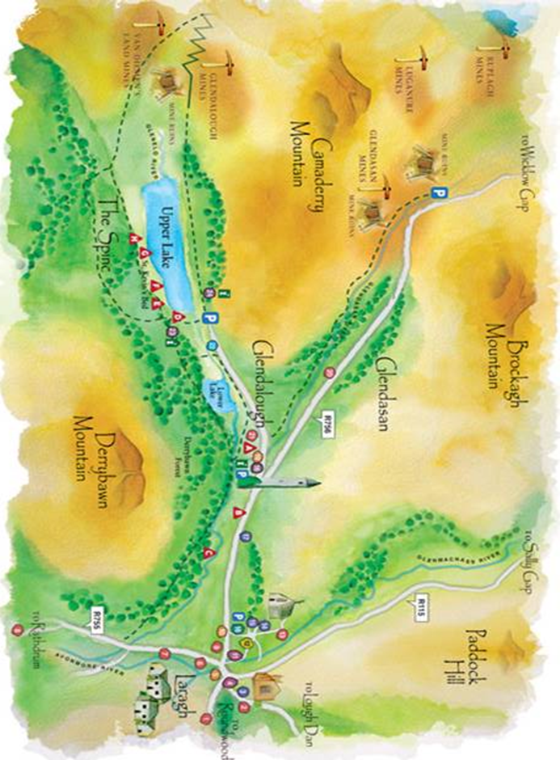
Map of Glendalough
Reproduced with the kind permission of
The Glendalough Mining Heritage Project

“Camino de Glendalough”

The idea of a "Camino de Glendalough" was first suggested at a West Glendalough Rural Deanery meeting in Blessington when we met to discuss possible ideas for the year of "Come and C".

Origins of Pilgrimage Idea

The pilgrim idea lies deep in the human heart and can be found in all the major religions. In Judaism, for instance, the focal point of pilgrimage was, and still is, the Holy City of Jerusalem. During major festivals like Passover and Tabernacles, thousands of faithful Jews at home or abroad, would go on pilgrimage there to celebrate the memory of some momentous event in their long history and also to reinforce their own sense of identity as a special people chosen by God. We see examples of these festive celebrations in John's Gospel, where they are portrayed as key occasions in the life of Jesus.

Motives

Why do people go on pilgrimage? What makes them put aside the usual business of life and take on the discomfort, inconvenience and even risk inherent in the pilgrim path? The earliest Christian pilgrims, as we have seen, went to places in the Holy Land associated with the life, death and resurrection of Jesus.

Early Irish monks, it would seem, were particularly fond of going into voluntary exile, in many cases never to return, and all for the sake of Christ and his gospel. They regarded exile as a 'white martyrdom', that is, a compensation for their lack of opportunity to shed their blood for their faith like the martyrs of old. These early Irish exiles were known for their wanderlust and adventurous spirit, and took as their inspirational text the injunction found in the Book of Ruth: "Leave your country and your father's house, and go into the land that I will show you." They founded many famous monasteries, including Glendalough.

Today's pilgrims have different reasons for their journey, such as coming to terms with the death of a loved one, the sudden loss of a job, the onset of a threatening disease, the breakup of a close relationship, the urge to find meaning in life, the wish to give thanks, or simply ask for a blessing. There is a renewed interest in the idea of pilgrimage. Every pilgrim, it would seem, undertakes not one but two journeys – a physical journey, containing challenge, adventure and some degree of discomfort, and at the same time an inner journey or quest for meaning and understanding, and for what could be called the reawakening of the spirit within.

Blessington Parish and especially St. Kevin's church in Hollywood have links with St. Kevin and Glendalough which stretch back into the mists of time.

If you plan to start your Camino from West Glendalough, St. Kevin's Church in Hollywood will be your first stop.

St. Kevin’s Church in Hollywood

St. Kevin's is a 17th Century church and has long been a "Pilgrim Church" where pilgrims would have received a blessing as they made their way to Glendalough on the ancient pilgrim routes over the Wicklow Gap.

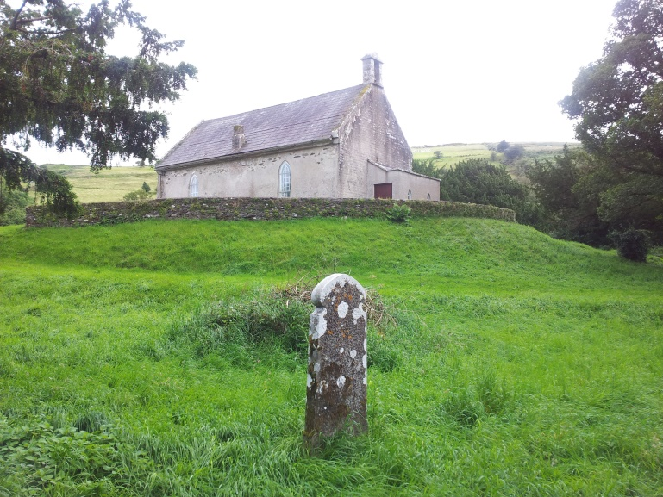
St. Kevin’s Church, Hollywood

St Kevin's Way

St. Kevin's Way begins at either Hollywood or Valleymount, wends its way through the King' s River valley, climbs over the Wicklow Gap and begins the descent through Glendassan, finally ending up at the old monastic site of Glendalough.

We know little enough for certain about Kevin beyond the following sparse outline of his life. He was born around the middle of the sixth century, near Tipperkevin in County Kildare, about five miles from Blessington. He belonged to the noble family of the Dál Messe Corb, who had settled in the fertile Liffey valley west of the Wicklow Mountains. At the tender age of twelve years, Kevin was entrusted to the care of three monks, said by some to have belonged to the monastery of Kilnamanagh, near Tallaght in Co Dublin. There, he learnt to become a monk himself but he was not content to spend a lifetime in the monastery.

He yearned instead for the solitude of a hermit's cell, and in obedience to this inner call, ran away and was led by an angel, so the story goes, over mountains and through valleys until he reached Glendalough, where he became a recluse. But he was quickly discovered and had to return to his monastery, where his fame for holiness at length persuaded his mentors to allow him his freedom. He was ordained priest and then gathering around him a few followers of his own, eventually made his way back to Glendalough, where in time he founded what was to become one of the best known of the old Irish monasteries.

Kevin died in 618 A.D.

As the years went by, Kevin's monastery grew in numbers and in fame, and more and more people made their way to Glendalough to pray at his burial place. Thus it was that a pilgrim path developed and became known as one of the great pilgrimage routes in medieval Ireland.

From St. Kevin's Hollywood you proceed on your pilgrimage to Glendalough along the R756. After three miles or so, the road is joined by the R758, which follows an alternative pilgrim route beginning at Valleymount. It is worth noting that it was at this junction that the celebrated labyrinth stone was discovered in 1908. The stone was transferred to the National Museum in the 1930s and in more recent times was placed in the heritage centre in Glendalough, where it is worth taking the time to view it.

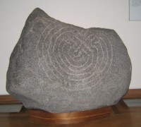
Hollywood Labyrinth Stone, Glendalough Heritage Centre

The labyrinth idea has a long history going back as far as ancient Egypt and Greece, and is also recognised as a Christian pilgrimage symbol – a good example of the latter can be seen on the floor of Chartres Cathedral in France, where medieval pilgrims crawled around it on their knees. This practice was known as walking the Jerusalem mile because it was regarded as a substitute for undertaking the longer and more dangerous pilgrimage to Jerusalem itself.

The design of the labyrinth – a spiral pathway leading from an open entrance through various obstacles to a final inner space of rest – suggests a hidden meaning, namely the journey that we all have to make from birth to death.

At the top of the Wicklow Gap, it will be worth pausing a short while to take stock of your surroundings. You are now at the crossing point between two magnificent mountain valleys, Glendasan to the east and Kings River to the west.

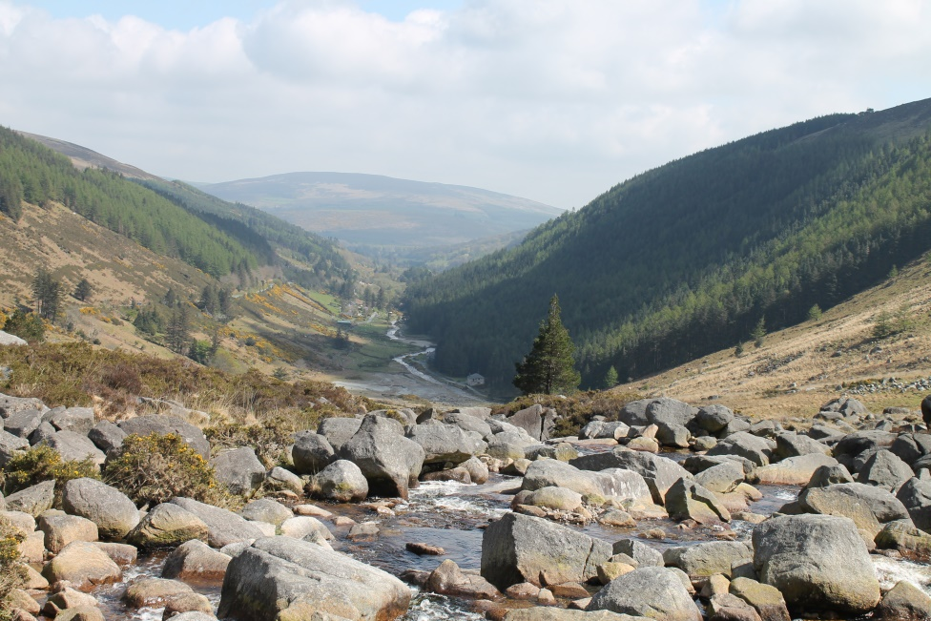
Glendasan Valley

As we leave the Wicklow Gap behind us, the road begins the long descent towards the Glendassan valley, and after a mile or so you pass the ruins of the old lead mines, where at their peak an 800 strong community of men, women and children toiled. Besides lead, the mines also produced copper and zinc.

Shortly after the lead mines, you reach a car-park at the head of Glendassan valley and here it is possible to join the ancient pilgrim path as it drops down fairly steeply to the valley floor. The steps of the pathway are clearly defined and can be negotiated safely with a little care. The credit for restoring the pathway belongs to the Pilgrim Paths Project which was set up in 1997 by the National Heritage Council to develop a network of walking routes along medieval pilgrim paths in association with local communities.

The descent to Glendassan should take about an hour. The route makes its way through the final mile or so of wooded and riverine landscape to your destination. The going is relatively easy, the view magnificent and the first sight of the monastery's round tower will be for many people a new experience.

If you plan to start your Camino from East Glendalough, St. John's Church in Laragh will be your first stop.

St. John's Church in Laragh

Glendalough and Laragh are in the ancient parish of Derralossary which is on record from at least the thirteenth century. In the year 1843 a Subscription was opened by the parish to fund the building of 'the new church in Laragh'. It was to be a Chapel of Ease, for the convenience, or ease, of the parishioners within its immediate vicinity. St. John’s was not dedicated until 1867. The bell in the tower, was cast in 1872, 5 years after the church was dedicated. St. John’s is no longer a Chapel of Ease, but is part of Rathdrum parish.

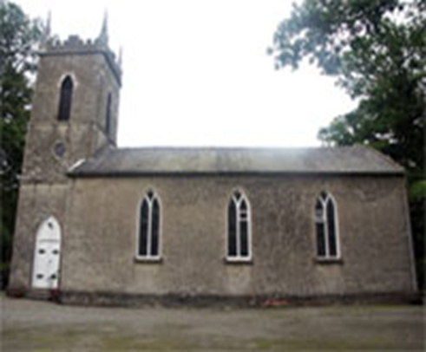

St. John’ Church, Laragh

Glendalough

The modern visitor's first impression of Glendalough, is far different from what Kevin himself would have experienced when he first arrived there some thirteen hundred years ago. Kevin came in search of silence and solitude, and would have found little evidence of human habitation in the valley he chose to make his home. Tradition has it he first dwelt in a makeshift cell on the southern shore of the upper lake and later moved down the valley to where two rivers meet, the Glenealo from Glendalough and the Glendassan River from the nearby valley. It was on this site that over the following five hundred years a great monastery grew up, thrived and eventually declined as the old Irish order gave way to a new pattern of church organisation based on dioceses.

The earliest buildings of the monastery would have been small, unpretentious and mostly wooden. As time went on, however, especially by the 11th and 12th centuries, the wooden structures were replaced by more imposing stone buildings.

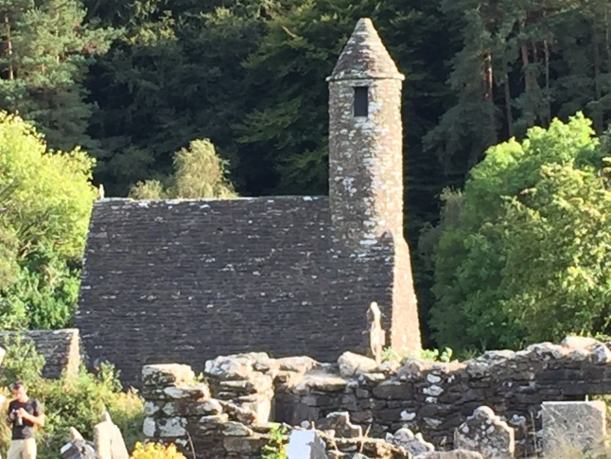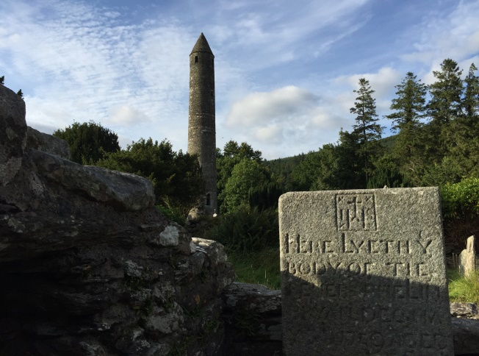

There are several walking routes around Glendalough, but probably the most accessible one is the one known as the Green Route.

Green Road Walk (Green Route)

Grade: Easy Distance: 3km Time: 50 mins Climb: 20m

The Green Road is an easy stroll on mostly flat ground. This walk passes through the Glendalough oak woodlands before dropping down onto the Lower Lake wetland edge. Views up the valley from the boardwalk here are spectacular. Lizards and dragonflies are often seen sunning themselves on the wooden trackway. The wetlands are a valuable breeding place for frogs.
Reefert Church is not too far from where Kevin first made his home. This area is traditionally called 'Disert Caomgen', or Kevin's wilderness, a fitting place in which to end our pilgrimage. The name of the church, 'Reefert', roughly translated as royal graveyard, refers to the tradition that several of the kings of Leinster chose to be buried there so that at the day of resurrection they would be sure to rise again with Kevin.

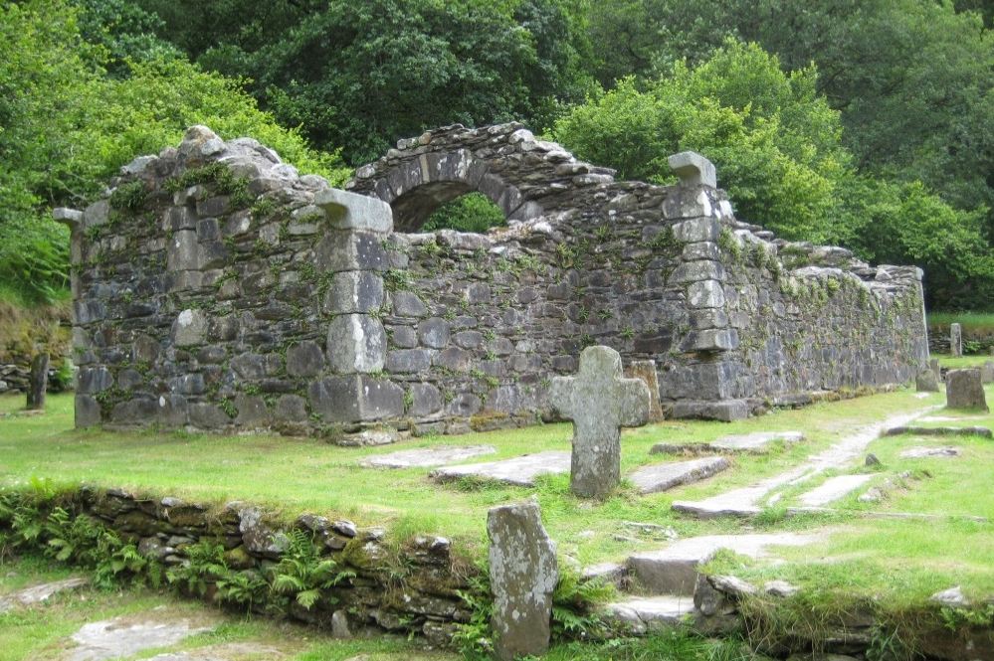
Reefert Church

What can we take away from our pilgrimage? We will all have come with different thoughts and expectations but hopefully we will depart carrying in our hearts something of the peace and beauty of a unique part of our heritage, something from deep in our past that can still have meaning for us.

This booklet is offered as a resource for the 800th anniversary of the uniting of
Dublin & Glendalough Dioceses.
With thanks to: Mr. Anton Trant, Blessington Interfaith Group,
Rev. Brian O’Reilly, Rector Rathdrum Parish, Rev. Leonard Ruddock, Rector Blessington Union of Parishes, and The Glendalough Mining Heritage Project for material used in the making of this booklet.

Reflections

PRAYER FOR PILGRIMS

May the God who called our father Abraham to journey into the unknown,
And guarded him and blessed him, protect me too and bless my journey.
May his confidence support me as I set out, may his Spirit be with me on the way,
And may he lead me back to my home in peace.
Those I love, I commend to his care. He is with them, I shall not fear.
As for myself, may his presence be my companion,
so that blessing may come to me and to everyone I meet.
Blessed are you, Lord, whose presence travels with his people.

_____________________________________

“Show me your ways, Lord, teach me your paths.” Psalm 25:4

The Green Road, most likely, would have been part of the ancient pilgrim way that leads to Saint Kevin’s Desert.
The road itself symbolises both journey and destination for us.
In order to reach any destination, we must undertake a journey.
While you walk along the road today,
take time to reflect upon the road that you are taking in your own life.
Also, consider your eternal destination and invite your heavenly Father to lead your life, to direct your steps and to form his plans and purposes in you.
_________________

“Enter his gates with thanksgiving and his courts with praise; give thanks to him and praise his name.” Psalm 100:4

‘Gated community’ is a comparatively new term to our world and symbolises much that is exclusive and, in some respects, uninviting. Many modern residential developments are designed to keep occupants safe within their fenced perimeter at the exclusion of the wider community.
This contrasts greatly with the community that once existed within the gates of the Monastic City, and, also with that of the community of God, Father, Son and Holy Spirit. In these cases, the individual was, and is, made to feel welcome to enter in and enjoy holy fellowship.

As you ascend the steps today, know that you are welcome, indeed, that you are valuable in the sight of your heavenly Father. Allow thanks and praise to bubble up from the depths of your being as you venture through these ancient gates.
_________________

“The name of the Lord is a strong tower; the righteous run into it and are safe.” Proverbs 18:10

The initial sight of the Glendalough round tower, looming in the distance, undoubtedly, raised the flagging spirits of bygone pilgrims, as they realised that St. Kevin’s stomping ground was now within their reach.
This glorious landmark truly symbolises many of the noble characteristics of our heavenly Father. In a sense, the tower forces us to look upward, to take our gaze away from the temporal and to glimpse the eternal.
Today, as we look upwards, we are empowered to realise that our Father, from his heavenly vantage point has a better perspective on our lives, and, that as we listen to his affirming voice, that he willingly guides our feet to green pastures.

Grant Lord, as I draw close to you that I will know your inspiring voice,
and that I will realise the safety of your beautiful presence.

God of our pilgrimage,
you have led us to the living water:
refresh and sustain us
as we go forward on our journey,
in the name of Jesus Christ our Lord.

