United Dioceses of Dublin & Glendalough

Diocesan Cycle of Prayer 2020-2021

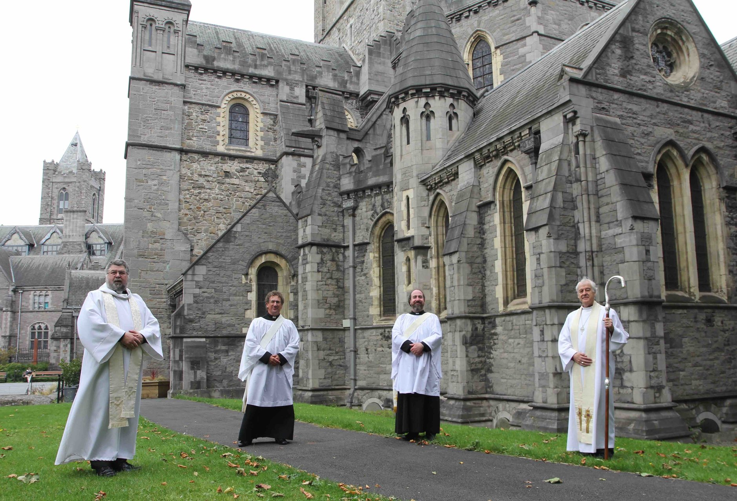
Deacons 2020
Alistair Doyle and Leonard Madden

Remember each month one Diocese of the Church of Ireland
December: Limerick & Killaloe
January: Armagh
February: Clogher
March: Derry & Raphoe
April: Down & Dromore
May: Connor
June: Kilmore, Elphin & Ardagh
July: Tuam, Killala & Achonry
August: Dublin & Glendalough
September: Meath & Kildare
October: Cashel, Ferns & Ossory
November: Cork, Cloyne & Ross
December: Limerick & Killaloe

FOREWORD

Psalm 143.1: Hear my prayer, O Lord, and in your faithfulness give ear to my supplications; answer me in your righteousness.

During 2020, gathering to worship, like other forms of gathering, came to a staggering and a sudden halt. Perhaps as never before we saw immediately the power of the Diocesan Cycle of Prayer. As well as praying for ourselves and for those we love, and also for the nation and for those who make decisions for the wellbeing of us all, we were able to keep prayer alive and personal for our own parishes and for the parishes of others in the confidence that the other parishes were praying for us and for our parish as we were praying for them. In fact, the move to on-line worship meant that anyone anywhere could and did know that our prayer was something that instantly took us beyond ourselves and showed something of careful concern for others.

Parishes are communities within communities. We always need to move into being communities outside our own restricted boundaries and mindsets. Engagements with others in the practicalities of life during The Lockdown gave us the opportunity to give and to take, to offer and to receive, kindness in whatever practical and useful ways we were able to. A vibrant life of prayer has enabled us to centre the complexities and the confusions, the bereavements and the sadnesses, of the time of the coronavirus in the Three Persons of the One God, the Lord of Creation, the Lord of Healing and the Lord of Comfort. This has been a constant source of inspiration to us as we have greeted each new day in a combination of hope and fear.

The Diocesan Cycle of Prayer has also kept us in close touch with members of our companion diocese of Jerusalem and the Middle East. Each part of the world is touched and scorched by the coronavirus and to know that we have the prayers and the blessing of The Children of Pentecost is a wonderful addition to our spiritual armour.

2021 may be similar to 2020 or it may be significantly different. At this stage, none of us knows for certain what it holds and what it will bring. Prayer is for us an anchor in the uncharted waters of faith, hope and love. I therefore wish to thank The Editor, the Reverend Canon Mark Gardner for all of his painstaking work in the compiling of this Cycle of Prayer. I hope that you find it as useful as do I throughout the year every year.

Psalm 126.4: The Lord has indeed done great things for us, and therefore we rejoice.

+Michael

Links

The Diocesan website and the Cycle of Prayer (a weekly cycle)
http://dublin.anglican.org/resources/cycle_of_prayer.php

The most recent Porvoo Prayer Calendar (a weekly cycle)

http://porvoocommunion.org/prayer-diary-2020/

The Anglican Communion website and Cycle of Prayer (a daily cycle)
http://www.anglicancommunion.org/resources/cycle-of-prayer/download-the-acp.aspx
The Mothers’ Union Cycle of Prayer
https://www.mothersunion.org/what-we-do/faith-and-prayer/midday-prayers-wave-prayer

The Diocesan Cycle of Prayer is published by the Diocesan Office
in time for the Diocesan Synods in October, and edited by Canon Mark Gardner,
who will always be pleased to receive suggestions and corrections.
email. markgardner@eircom.net (or) mobile 087-2660228 & txt

Diocesan Cycle of Prayer 2020 -2021 Year B

29 November - the First Sunday of Advent Violet

the Parishes of Arklow, Inch and Kilbride
the clergy, Kevin Conroy

Ordinands, and staff of the Theological Institute
Maurice Elliott, Paddy McGlinchey,
Katie Heffelfinger and Bridget Nichols

Students in Pastoral Placements
the Representative Church Body and the staff of Church House

6 December - the Second Sunday of Advent Violet

the Parishes of Athy, Kilberry and Fontstown with Kilkea
the Rector, Olive Donohoe
The Diocesan Committee for Social Action
St Paul’s Arab-Anglican Church, West Jerusalem

13 December - the Third Sunday of Advent Violet

the Parishes of
Blessington, Manor Kilbride, Ballymore-Eustace and Hollywood
the clergy, Leonard Ruddock and Leonard Madden

The Church Army
Redeemer Arabic-speaking Church, Jabal Amman, Jordan

20 December - the Fourth Sunday of Advent Violet

the Parishes of Booterstown, Carysfort and Mount Merrion
the Rector, Gillian Wharton

USPG, United Society Partners in the Gospel
St Paul’s Church, Amman, Jordan
Friday 25 December - Christmas Day White

27 December - the First Sunday of Christmas White

the Parish of Bray
the Rector, Baden Stanley

Brabazon House and the chaplain, Adrian Empey
PACT (formerly the Protestant Adoption Society)

3 January - the Second Sunday of Christmas White

the Parishes of Castleknock and Mulhuddart with Clonsilla
the Rector, Paul Houston

CMS Ireland and worldwide
St George's Cathedral, Jerusalem

10 January – the First Sunday after the Epiphany White
the Baptism of our Lord

the Parishes of Castlemacadam, Ballinatone and Aughrim
the Rector,

Uniformed Youth Organizations
the Theodore Schneller Chapel, Amman, Jordan

17 January - the Second Sunday after the Epiphany White

the Parishes of Celbridge and Straffan with Newcastle-Lyons
the Rector, Stephen Neill

Ecumenical Councils of Churches in Ireland and abroad
St Luke’s Church, Marka, Jordan

Monday 18 January
Week of Prayer for Christian Unity begins
24 January – the Third Sunday after the Epiphany White
the Parishes of Clondalkin and Rathcoole
the clergy, Alan Rufli and Martin O’Connor

the Irish School of Ecumenics in Dublin and Belfast
the Saviour Church, Al-Zarqa, Jordan

31 January – the Presentation of Christ in the Temple White

the Parish of Clontarf
the clergy, Lesley Robinson and Anne Lodge
the 2021 Diocesan Clergy Conference

7 February – the Second Sunday before Lent Green
the Parish of Crumlin and Chapelizod
the Rector, Ruth Noble

Crinken Church,
the Pastor, Trevor Stevenson
Crosslinks, the international mission society

14 February – the Sunday before Lent Green
Transfiguration Sunday White
the Parish of Dalkey
the Rector, Bruce Hayes

Christian Aid, and Bishops’ Appeal
the Virgin Mary Arab Episcopal Church, Irbid, Jordan

17 February – Ash Wednesday Violet

21 February - the First Sunday in Lent Green
the Parish of Delgany
the Rector, Nigel Waugh

Cumann Gaelach na hEaglaise ~ The Irish Guild of the Church
the Good Shepherd Church, Salt, Jordan
28 February - the Second Sunday in Lent Violet

the Parishes of Donoughmore, Donard and Dunlavin
the Rector, Neal O’Raw

the Church’s Ministry of Healing; Bruce Hayes, Diocesan chaplain
St John the Baptist Church, Husun, Jordan

7 March - the Third Sunday in Lent Violet

the Parishes of Irishtown and Donnybrook
the Vicar, John Marchant

the King's Hospital (School) and the Chaplain, Peter Campion

14 March – the Fourth Sunday in Lent Violet
Mothering Sunday

St Patrick's Cathedral
the clergy, William Morton and Charles Mullen
the Anglican Communion

21 March – the Fifth Sunday in Lent Violet

the Parishes of Drumcondra, North Strand and St Barnabas
the Rector, Garth Bunting

the Church of Ireland Centre, Dublin City University
St Peter's & St. Paul's Church, Aqaba, Jordan

28 March – the Sixth Sunday in Lent (Palm Sunday) Violet

the Parishes of Dunganstown, Redcross & Conary
the Rector, Roland Heaney

Mothers Union Ireland, providing Christian care for families
St Andrew’s Anglican Episcopal Church, Ramallah, West Bank
4 April – Easter Day – the First Sunday of Easter White
the Parish of Dún Laoghaire
the Rector, Ása Björk Ólafsdóttir

Dún Laoghaire Life Boats, of which she is Chaplain
St Peter’s Church, Birzeit, Ramallah, West Bank

11 April – the Second Sunday of Easter White
the Parish of Greystones
the clergy, David Mungavin, and Rebecca Guildea

The Church of Ireland Marriage Council
Good Shepherd Church, Rafidia, Nablus, West Bank

18 April – the Third Sunday of Easter White
the Parish of Glenageary
the Rector, Gary Dowd

Sunday Schools, teachers and volunteers
St Phillip Church, Nablus, West Bank

25 April - the Fourth Sunday of Easter White

the Parishes & Churches of Holmpatrick, Balbriggan & Kenure
the clergy, Anthony Kelly and Tom O’Brien

the Parish of Howth, and the Rector, Kevin Brew
Trinity College Dublin, and the Dean of Residence, Steve Brunn

2 May - the Fifth Sunday of Easter White
the Parish of Killiney, Ballybrack
the Rector, William Olhausen

the Parish of Killiney, Holy Trinity
the Rector, Gary Hastings

Christian Aid Week begins 9 May
9 May – the Sixth Sunday of Easter White

the Parish of Kill o'the Grange,
the Rector, Alan Breen

General Synod 13–15 May, Armagh

13 May – the Ascension Day White

16 May – the Seventh Sunday of Easter White

the Parish of Kilternan
the clergy, Rob Clements and Alistair Doyle

Glebe House, Kilternan
(incorporating Glenindare,
Harcourt Home and Alexandra Guild House)

23 May – the Day of Pentecost (Whit Sunday) Red

St Catherine’s Church, Thomas Street

City Outreach through Renewal and Evangelism
the Minister, Eoghan Heaslip

The Solas Project, Dublin 8

30 May - Trinity Sunday White

Christ Church Cathedral
the clergy, Dermot Dunne and Abigail Sines

Non-stipendiary ministers, and clergy with permission to officiate

The Cathedral Group of Parishes
the clergy, David Pierpoint and Ross Styles

6 June – the First Sunday after Trinity Green
the Parishes of Leixlip & Lucan
the Rector, Scott Peoples

Youth Ministry,
Greg Fromholz, coordinator of Ministry to Young Adults
Susie Keegan, Diocesan Youth Ministry Development Officer

13 June – the Second Sunday after Trinity Green

the Parishes of Malahide, Portmarnock, & St Doulagh’s Balgriffin
the Rector, Norman Gamble

SPCK, the Society for Promoting Christian Knowledge

20 June- the Third Sunday after Trinity Green

the Parish of Monkstown
the Rector, Roy Byrne

the Diocesan Communications officer, Lynn Glanville

St Matthew’s Anglican Episcopal Church, Zebabdeh, West Bank

27 June – the Fourth Sunday after Trinity Green

the Parishes of Narraghmore, Timolin, Castledermot & Kinneagh
the clergy,

St Paul’s Church, Shefa’amr, Northern Israel
The mission partners of all mission societies linked to Parishes

4 July – the Fifth Sunday after Trinity Green
the Parishes of Newcastle & Newtownmountkennedy with Calary
the Rector,

Diocesan Youth Camps
11 July - the Sixth Sunday after Trinity Green

the Parishes of Powerscourt with Kilbride
the Rector, Cathy Hallissey

Hospices and home-care services
Holy Family Church, Reineh, Israel

18 July - the Seventh Sunday after Trinity Green

the Parishes of Raheny & Coolock
the clergy, Norman McCausland and Ashling Shine

Hospital chaplains
Patrick Ryan and Hilda Plant

25 July - the Eighth Sunday after Trinity Green
St James the Apostle Red
the Parish of Rathfarnham
the Rector, Adrienne Galligan

Eco-Congregation Ireland,
an ecumenical project of the Irish Inter-Church Meeting

1 August - the Ninth Sunday after Trinity Green

the Parishes of Rathdrum & Derralossary with Glenealy
the Rector, Brian O’Reilly
the Leprosy Mission (TLM) Ireland

8 August - the Tenth Sunday after Trinity Green

the Parish of Rathmichael
the priest in charge, Terry Lilburn

15 August - the Eleventh Sunday after Trinity Green

the Parish of Rathmines with Harold’s Cross
the Rector, Robert Jones

Schools under Church of Ireland management

22 August – the Twelfth Sunday after Trinity Green

the Parishes of St Ann with St Mark and St Stephen
the clergy, David Gillespie and Yvonne Ginnelly

The Mission to Seafarers, Willie Black, Dublin Port Chaplain

29 August - the Thirteenth Sunday after Trinity Green

the Parishes of St Bartholomew and Christ Church Leeson Park
the Vicar, Andrew McCroskery

Growing in covenant relationship with the Methodist Church

5 September - the Fourteenth Sunday after Trinity Green

The Parish of St Catherine & St James with St Audoen
the Rector, Mark Gardner
The Dublin congregation of the Church of South India
St John’s & St Luke’s, Haifa, Israel

12 September - the Fifteenth Sunday after Trinity Green

the Church of St John the Evangelist, Sandymount
the chaplain, Fr Paul Barlow

St John’s House, Merrion Road
the chaplain, Andrew McCroskery
All Saints Episcopal Church, Beirut, Lebanon
19 September - the Sixteenth Sunday after Trinity Green

the Parishes of Sandford & Milltown
the clergy, Sonia Gyles and Anne-Marie O’Farrell

The Mageough - independent living complex,
and the chaplain, Robert Kingston

26 September - the Seventeenth Sunday after Trinity Green

the Parishes of Santry, Glasnevin & Finglas
the Rector, David Oxley

The Church of Ireland Association of Deaf People
St Peter’s Church, Jaffa, Israel

3 October - the Eighteenth Sunday after Trinity Green
the Parish of Taney
the clergy, Robert Warren, Nigel Pierpoint,
and Christopher West
The Diocesan Synods, meeting Wednesday 6 October
The Diocesan councils, the Diocesan office and staff

10 October - the Nineteenth Sunday after Trinity Green
the Parishes of Stillorgan & Blackrock
the clergy, Ian Gallagher and Robert Marshall

The Dublin University Mission to Chota Nagpur

17 October – the Twentieth Sunday after Trinity Green

the Parishes of
Swords, Clonmethan, Kilsallaghan, Donabate & Lusk
the Rector, Neal Phair

The South American Missionary Society
Christ Church, Nazareth
24 October - the Fifth Sunday before Advent Green
Bible Sunday

the Parish of Tallaght
the clergy, William Deverell and Avril Bennett

Hospices and home-care services

The Dublin University Far Eastern Mission

31 October – the Fourth Sunday before Advent Green
All Saints Sunday White

the Parish of Tullow
the Rector, John Tanner

Diocesan Lay Readers, Parish Readers, and Lay Ministers

The Saviour Church, Kufr-Yasif, Israel

7 November – the Third Sunday before Advent Green
Remembrance Sunday Violet

the Parish of Whitechurch
the clergy, Horace McKinley, and Michael Heaney

St Columba's College
and the chaplain, Daniel Owen

14 November – the Second Sunday before Advent Green

the Parishes of Wicklow & Killiskey
the clergy, Jack Kinkead, and Ken Rue

The Church Music Committee

Musicians, singers, instrumentalists and ringers
21 November - the Kingship of Christ White

the Parish of Zion (Rathgar)
the Rector, Stephen Farrell

'Come & C' an initiative centred around the Five Marks of Mission of the Anglican Communion

28 November - the First Sunday of Advent Violet

the Parishes of Arklow, Inch and Kilbride
the clergy, Kevin Conroy

Ordinands, and staff of the Theological Institute
Maurice Elliott, Paddy McGlinchey,
Katie Heffelfinger and Bridget Nichols

