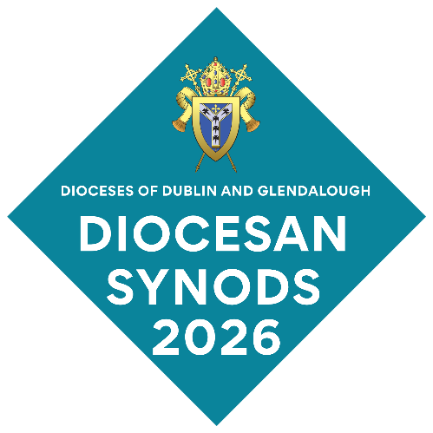
Welcome to Diocesan Synods 2026 Fáilte!

An invitation to Diocesan Synods – Saturday, 17 October 2026, 10.00AM – 5.00PM
You are warmly invited to the Diocesan Synods of the United Dioceses of Dublin and Glendalough. We look forward to seeing you at Alexandra College, Milltown, Dublin 6, on Saturday, 17 October 2026. If this is your first time coming to Synods, you are especially welcome! Fáilte roimh gach éinne!
We hope this leaflet will help you to participate fully in Synods and answer your practical questions.

To meet, to worship, to reflect and to plan for the future
At Synods, clergy and lay representatives of every parish come together with our Archbishop to worship and to reflect on how the work of the Church in the Dioceses has progressed in the last year. We share experiences and learn by listening to each other as the Holy Spirit guides and inspires us. Most importantly, we think about the future of the Church – how to recognise opportunities and tackle challenges in our parishes and in the United Dioceses.
Your participation is vital. We would love to see you at Synods. We hope that you will feel encouraged to listen, to contribute, and share your views and experiences. That will help all of us, and our Diocesan committees and organisations, to better advance God’s message in the communities in which we live.

We are trying a new approach to Synods this year
During the last year, Diocesan Councils reviewed in detail how Synods operate. We conducted an online survey of Synod members as part of this review. (A summary of the review findings will be available on the Diocesan Office table in the meeting hall at Synods).
You told us how much you valued Synod meetings, and you shared many ideas with us about how the meetings could be improved. We have taken on board many of your suggestions this year and plan to implement more changes next year. Whether this is your first time at Synods or you have been at Synod before, we would love to hear from you about your experiences this year, and how we could improve Synods next year.

Diocesan Synods at Alexandra College, Milltown, Dublin D06 T2V0
To Ranelagh
St Philip’s Church
Temple Road:
Opening Service 10.00AM
Stalls in the Ledbetter Hall
Henrietta White Sports Hall:
Synod Meeting held here from 11.00AM
Free public car park Milltown Road
Opposite
Wilde & Green Café
Limited free parking on Orchard Road
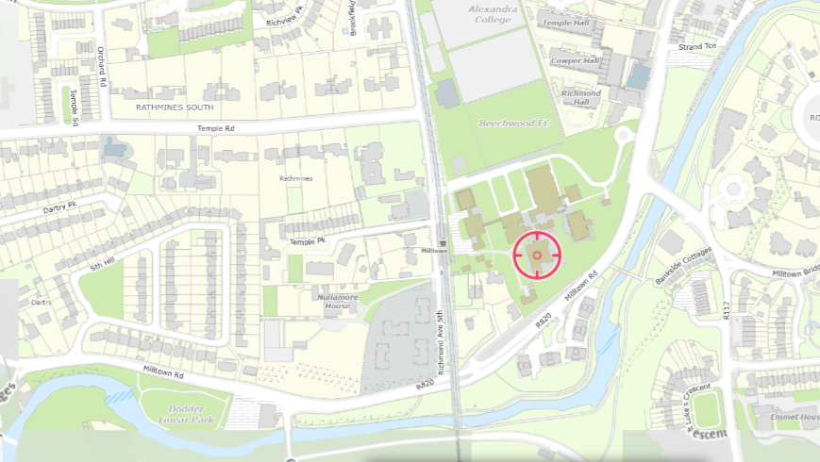
To Rathmines
To Dundrum
Luas to Dundrum
Milltown Road entrance to Alexandra College: Limited parking
Bus stops Route 44
Bus stops Route S4
Lunch in Alex Eats Building
Milltown LUAS stop Green Line
Dropping Well pub
Richmond Ave South Gate to Alexandra College: ideal if using the Luas
Parking on Temple Road (charges up to 13.00 on Saturday)

Getting to Synods
LUAS
Luas Green Line stops at Milltown. The Richmond Avenue South Gate of Alexandra College is beside this stop. This is the best way to get to Synods. The Henrietta White Sports Hall, where Synods will be held, is directly to the left inside the Richmond Avenue South Gate.
Luas Park and Ride facilities are available at:
- Carrickmines Luas Stop: Located off Meadowfield, Brennanstown, Dublin 18 – use Junction 15 off M50 motorway
- Stillorgan Luas Stop: Located on Blackthorn Drive in Sandyford Industrial Estate
- Sandyford Luas Stop: Located on Blackthorn Avenue in Sandyford Industrial Estate
- Balally Luas Stop: Located near Dundrum Town Centre
Car parking for one day costs less than €5 at any of these Park and Ride facilities.

BUS
Bus route S4 (Stop 7952 on Milltown Road and Stop 7948 on Dundrum Road)
Bus route 44 (Stops 2817 and 2898 on Milltown Road)
The Transport for Ireland App is available to download at TFI Live App - Transport for Ireland. Its journey planner section will help you to plan your journey and give you departure and arrival times.

CAR
Car parking is very limited in the area. You may be able to use:
- Paid parking (charges up to 13.00 on Saturday) in Temple Road
- Limited free parking in Orchard Road
- Free public car parking on Saturdays opposite Wilde & Green Café, Milltown Road
- Some limited parking in Alexandra College, at Milltown Road entrance only.
If you must use your car, please:
- Car-pool with others coming to Synods
- Don’t block entrances or cause obstructions
- Note that parking is at your own risk – please don’t leave valuables visible in your car.

CYCLE
You can lock your bike in the cycle racks at Alexandra College. Parking is at your own risk.
What will happen at Synods?
Holy Communion: St Philip’s Church, Temple Road, D06 AX71
Our meeting of Synods begins with a service of Holy Communion in St Philip’s Church, Temple Road at 10.00AM on Saturday morning. We are grateful to St Philip’s Parish for hosting this service which sets the whole context for our meeting.
Synods meet in Henrietta White Sports Building, Alexandra College
11.00AM to 1.15PM and 2.15PM to 5.00PM

We will register and enjoy a cup of coffee/tea from 11.00-11.30AM, and business will begin at 11.30AM. You will find a full agenda enclosed with this leaflet.
The work of Synods includes sessions where we will:
- Hear from Archbishop Jackson about priorities for the work of the Dioceses in the coming year
- Elect members to various committees and positions. Because this year is the first year of the 2026-2028 triennium, we will have to fill a number of positions. Some of these will be nominated and filled at the Synods meeting; others will be decided by postal ballot after Synods. You will find a full list of the positions and committees in the table at the end of this leaflet.
- Complete formal business items, including receiving reports and scrutinising the financial accounts of the Dioceses
- Hear about and discuss the work that various committees and organisations do during the year and what they have planned for the coming year
- Listen to stories from two parishes about how they are growing their witness and work in their local communities; and we will think about how their experiences might help each of us in our own parishes
- Look forward to and discuss the next steps in the Mission Plan of the Dioceses.
We hope you will enjoy listening to the contributions, reflect on what you have heard, and share your questions and thoughts with fellow members of Synods.
Lunch in the Alex Eats Building, 1.15PM to 2.15PM
We will have a soup and sandwiches lunch in the Alex Eats Building. Alexandra College has kindly provided lunch, so there is no charge. Please let the Diocesan Office know if you have any special dietary requirements not later than 10.00AM on Wednesday, 14 October 2026.
Stalls in the Ledbetter Hall, 1.15PM to 2.15PM
Several Diocesan organisations and charities will have stalls in the Ledbetter Hall, just across the lawn from the Alex Eats Building. Do pop in and get the latest information and resources from the stall holders.
Afternoon session of Synods, 2.15PM to 5.00PM
The afternoon sessions will include presentations from two parishes and a break-out discussion session on how the Mission Plan can be advanced to the next stage.
Before you come to Synods
You will receive:
- The Agenda
- The Annual Report for Diocesan Synods. This replaces the Book of Reports that we used to use at Synods. It carries information about the work that has been going on in the last year throughout the Dioceses and details of the major tasks each organisation will be undertaking in the coming year.
- The Financial Statements for the Dioceses
- Attendance Badge – please wear this at all times
- Attendance Card – please post this in the Attendance Boxes inside the entrance to the meeting hall
- Nomination papers for various committees and positions.
Set aside a little time before you come to Synods. You could:
- Pray for the meeting and work of Synods, and for your fellow Synod members. There are helpful prayers in the Annual Report book.
- Read the Annual Report and the Financial Accounts that will be sent to you.
- Think about the contents of the Annual Report and these other documents, and the items on the Agenda. Have you questions about the activities covered? Have you any suggestions to improve how the work of some committees or organisations? Jot them down so that you can share them with members of Synods.
- Talk to your fellow representatives from your own parish. Share your views and think about any ideas that you may have about how to strengthen the work of the Church in your parish or in the Dioceses.
- Examine the nomination papers that will be sent to you with the Annual Report. Think about the names of Synod members that you would like to nominate to positions and committees and check with them that they are willing to stand for election. Fill in their names on the nomination papers or be ready to nominate them at the meeting.
- Think about whether you could offer skills and experience to the work of any of the committees and consider allowing your name to go forward for election.
- Plan your journey to Synods. The map and directions on pages 2 and 3 should help.
- If for any reason you are unable to attend Synods, Section 23 of Chapter 2 of the Constitution of the Church of Ireland allows for the first supplementalist to be summoned instead – provided that the “bishop or other person convening the meeting is satisfied that any synod member is unable to attend by reason of illness or other reasonable cause.” You need to let the Diocesan Office know by close of business on 15 October 2026 that you cannot attend, if a supplementalist is to attend in your place.
- A soup and sandwiches lunch will be provided. Please let the Diocesan Office know if you have any special dietary requirements not later than 10.00AM on Wednesday, 14 October 2026.
- If you would like to put down a formal motion for debate, you will have to submit the motion in writing to the Honorary Secretaries at the Diocesan Office not later than 10.00AM on Wednesday, 14 October 2026.
- You can also ask for more detailed information on any issue by writing to the Honorary Secretaries (at the Diocesan Office) at least a week in advance of Synods.

While at Synods
You can help all of us to make Synods an interesting, supportive and informative event.
When you arrive:
- Please wear your badge prominently. We don’t all know each other and sometimes we can forget a name!
- Come to the Service of Holy Communion in St Philip’s Church at 10.00AM
- Complete your registration card and put in it in the Registration Box at the entrance to the meeting hall.
- Switch your mobile phone OFF!
- Greet the people near to you at Synod. Often, new members especially, can be a bit overwhelmed or feel lost, and even experienced members can hesitate to begin a conversation. Introduce yourself and get to know your fellow Synod members before the Church Service and when you come into the meeting hall. Share some of your own parochial experiences with them!
During the day:
- Remember, Synod belongs to all of us and we all have a responsibility to make it as effective as we can! Your participation is vital.
- This year, we have asked that short presentations are used to introduce items and we have left time for questions and answers.
- You can ask questions and make contributions using a roving microphone at your seat – or from the podium. If you want to speak from the podium, come to the front so that you can get to the podium easily.
- Offer suggestions: Committees and organisations will really welcome suggestions from you on how to strengthen the plans that they have.
Before you leave:
- Post your completed nomination papers in the Nominations Box in the Hall before you leave Synods. Elections to the committees and positions covered by these nomination papers will be held by postal ballot.
- We will have a Suggestion Box on the Diocesan Office table in the meeting hall. Drop in any suggestion on how we can improve Synods next year.
- Pick up a copy of the Diocesan Cycle of Prayer: it will be available for collection from the Diocesan Office table in the meeting hall.
After Synods
It’s important to share news about the work of Synods with your fellow parishioners and members of the Select Vestry in your parish.
- Share your experience at Synods with the other Synod members from your parish. What were the big “take-aways” from the meeting for you? Are any of them relevant to the work of your parish?
- Tell your fellow parishioners about what was discussed at Synods and what you learned. Some Synod members do this at Church on the Sunday after Synods meet.
- Share what you have heard with the members of the Select Vestry in your parish. Would any of the ideas that you heard be helpful in your parish? Would you or someone from your parish like to share news of work going on in your parish at Synods next year?
- Put a copy of the Annual Report on the book stand in your Church or Parish Room where others can see it. Let people know that it is also available on the Diocesan website.
- Vote for members of committees and positions when you receive your ballot papers and return the ballot papers to the Diocesan Office by 5PM on 6 November 2026.
- Pray for the work that you heard about at Synods and the people that have been elected to carry on the work of the Dioceses in the year ahead.

Help us to improve next year’s Synods
You will receive a Survey Monkey online survey a short time after Synods. It will ask you about your experience of Synod 2026. It will also give you an opportunity to suggest improvements for next year. Please complete the survey – it will help us greatly to make Synods a more effective event for you and other members. Thank you in advance for helping us in this way.
Next year’s Synods will be held on Saturday, 16 October 2027. We look forward to seeing you there!

Contacts
Some useful contacts are:
Post: Honorary Secretaries of Diocesan Synods
c/o Diocesan Office, Church of Ireland House, Rathmines, Dublin 6
Email: dgsecretary@dublinchurchofireland.org
Tel: 01 496 6981

Positions and Committees to which members of Synods will be elected
Position/Committee | Role | How election takes place
Elections by the Synods of Dublin and Glendalough voting separately AT SYNODS
Honorary Secretary-Clerical (Dublin) | Acts as Honorary Secretary to Dublin Synod and to Dublin Diocesan Council.  The two Diocesan Synods (Dublin and Glendalough) and the two Diocesan Councils nearly always meet jointly. | Candidates are nominated (proposed and seconded) at Diocesan Synods by the clerical members from each Diocese respectively.  Voting, if required, takes place at Diocesan Synods, with clerical members from each Diocese voting separately and respectively.
Honorary Secretary-Clerical (Glendalough) | Acts as Honorary Secretary to Glendalough Synod and to Glendalough Diocesan Council.  As noted above the two Diocesan Synods nearly always meet jointly and similarly with the two Diocesan Councils.
Honorary Secretary-Lay (Dublin) | Acts as Honorary Secretary to Dublin Synod and to Dublin Diocesan Council – see above. | Candidates are nominated (proposed and seconded) at Diocesan Synods by the lay members from each Diocese respectively.  Voting, if required, takes place at Diocesan Synods, with lay members from each Diocese voting separately and respectively.
Honorary Secretary-Lay (Glendalough) | Acts as Honorary Secretary to Glendalough Synod and to Glendalough Diocesan Council – see above.
Honorary Treasurer-Dublin | Serves as Honorary Treasurer to the Diocesan Synods and to Diocesan Councils, and chairs the Glebes, Property and Finance Sub-Committee. | Candidates (lay) are nominated (proposed and seconded) at Diocesan Synods by the members from each Diocese respectively.  Voting, if required, takes place at Diocesan Synods, with clerical and lay members in each Diocese voting jointly.
Honorary Treasurer-Glendalough | Serves as Honorary Treasurer to the Diocesan Synods and to Diocesan Councils, and is vice-chair of the Glebes, Property and Finance Sub-Committee.

Position/Committee | Role | How election takes place
Elections by the Synods of Dublin and Glendalough voting jointly BY POSTAL BALLOT
Members of the Representative Church Body (RB) | The United Dioceses elects one clerical and two lay members to this body. To provide continuity, one member is elected each year and serves as a member of the RB for three years.  The RB is the central administrative body of the Church and its main task is to manage the financial and other assets of the Church. | Candidates are nominated by the clerical or lay members of both Dioceses depending on whether the election is for a clerical or a lay member. The election will be held by postal ballot.  If you wish to nominate a person for election, please write their name on the designated nomination paper in your Synod pack. Place the completed nomination paper in the Nomination Box in the meeting hall before Synods conclude.  Please note that nominations and voting is by orders. This means that clerical members may nominate and vote for clerical members only; and that lay members may nominate and vote for lay members only.
Episcopal Electoral College | Twelve clerical and twelve lay persons (and supplementalists) are elected at the beginning of each triennium to serve as members of this body. They participate in the selection of a new archbishop in the event of a vacancy in the see of Dublin and Glendalough.  The three clergy and the three lay members receiving the most votes also serve on Episcopal Electoral Colleges for other dioceses in the Province of Dublin. | Candidates are nominated separately by clerical and lay members of both Dioceses, with clergy of both dioceses nominating and voting jointly, and the laity of both dioceses nominating and voting jointly. The elections will be held by postal ballot.  If you wish to nominate a person for election, please write their name on the designated nomination paper in your Synod pack. Place the completed nomination paper in the Nomination Box in the meeting hall before Synods conclude. Please note that nominations and voting is by orders.
Complaints Committee | One clerical member and one lay member are elected from each Diocese to serve for a period of six years on this central Church committee. This Committee has a role in the processing of complaints about clergy. | Candidates are nominated separately by clerical and lay members of both Dioceses. The elections will be held by postal ballot.  If you wish to nominate a person for election, please write their name on the designated nomination paper in your Synod pack. Place the completed nomination paper in the Nomination Box in the meeting hall before Synods conclude.  Please note that nominations and voting is by orders.

Position/Committee | Role | How election takes place
Elections by the Synods of Dublin and Glendalough voting separately BY POSTAL BALLOT
General Synod Representatives | A number of clerical and lay persons (and supplementalists) may be elected to serve as members of this body. They attend General Synod each year on behalf of Dublin and Glendalough.  The General Synod is usually held in May but there may be other occasional (albeit infrequent) meetings of General Synod. | Candidates are nominated separately by clerical and lay members of each Diocese. These elections will be held by postal ballot.  If you wish to nominate a person for election, please write their name on the designated nomination paper in your Synod pack. Place the completed nomination paper in the Nomination Box in the meeting hall before Synods conclude.
Diocesan Committees of Patronage | Four clergy and one lay person (and supplementalists) are elected to serve as members of these Committees.  There are two separate Committees of Patronage, one for each diocese. The Committees have a role when a vacancy occurs in a parish.  A Committee of Patronage joins with the four parochial nominators from the relevant vacant parish, to form a Board of Nomination which is summoned by the Archbishop. The Board of Nomination nominates a potential candidate to the Archbishop for appointment to the vacant parish. | Candidates are nominated separately by clerical and lay members of each Diocese. The elections will be held by postal ballot.  If you wish to nominate a person for election, please write their name on the designated nomination paper in your Synod pack. Place the completed nomination paper in the Nomination Box in the meeting hall before Synods conclude. Please note that nominations and voting is by orders.

Position/Committee | Role | How election takes place
Elections by the Synods of Dublin and Glendalough voting separately BY POSTAL BALLOT
Dublin Diocesan Court | One vacancy exists in the Dublin Diocesan Court and one vacancy exists in the Glendalough Diocesan Court.  These bodies hear appeals in the respective Dioceses involving the laws of the Church and may be asked by the Archbishop to adjudicate on particular issues. The Courts in both Dioceses have not had to consider a case for many years but each diocese is required to have members of its Court in place. | Candidates are nominated separately by members of each Diocesan Synod, and the election will be held by postal ballot.  If you wish to nominate a person for election, please write their name on the designated nomination paper in your Synod pack. Place the completed nomination paper in the Nomination Box in the meeting hall before the conclusion of Synods.
Glendalough Diocesan Court

Elections by the Synods of Dublin and Glendalough voting jointly AT Synods
Appointment of scrutineers to oversee elections | Two clerical and two lay members are elected to act as scrutineers for the elections. | Candidates are nominated at Diocesan Synods by members (clerical and lay) from each Diocese.  Voting takes place at Synods, with clerical and lay members in each Diocese voting jointly.

_________________________________________

My notes / Mo nótaí

