##### United Dioceses of Dublin & Glendalough

##### Diocesan Cycle of Prayer 2023-2024

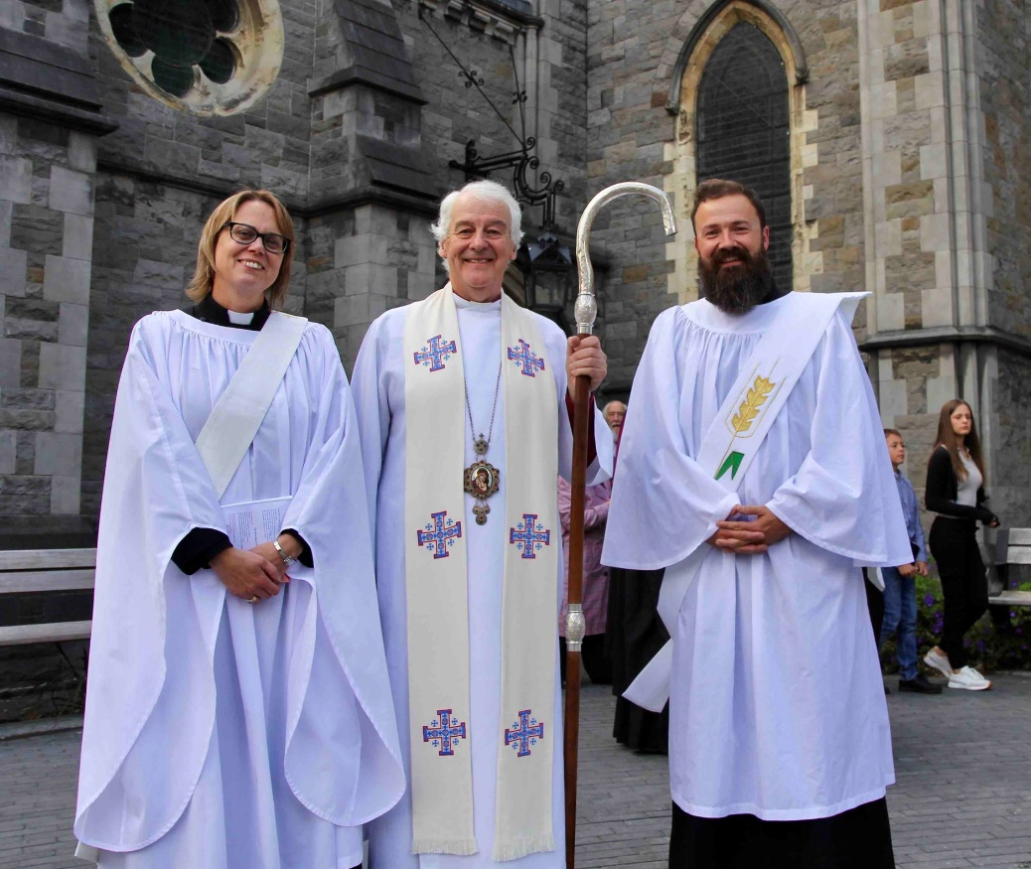

*On Sunday 17th September in Christ Church Cathedral Caroline Brennan and Mathew McCauley were ordained to the diaconate to serve in Monkstown and Irishtown parishes respectively.*

*On Sunday 24th September in Christ Church Cathedral Rev Jane Burns and Rev Scott Evans were ordained to the priesthood to serve in Taney and Holy Trinity Rathmines parishes respectively.*

*Remember each month one Diocese of the Church of Ireland*

*January:*  Armagh

*February:* Clogher

*March:* Derry & Raphoe

*April:* Down & Dromore

*May:* Connor

*June:* Kilmore, Elphin & Ardagh

*July:* Tuam, Limerick & Killaloe

*August:* Dublin & Glendalough

*September:* Meath & Kildare

*October:* Cashel, Ferns & Ossory

*November:* Cork, Cloyne & Ross

2023-2024 FOREWORD

Cycles turn. Cycles rotate. Cycles move. Cycles stall. Often, you will have heard the phrase:

There is no need to reinvent the wheel. The same wheel does not fit every bicycle or other

vehicle. So, as well as there being horses for courses, there are cycles for courses. A Cycle of

Prayer is the same in general as any other cycle. Its essential function is to turn day by day,

week by week, Sunday by Sunday as the parishes and the institutions of the United Dioceses

of Dublin and Glendalough travel together with God and with one another. Our Cycle of

Prayer has, nonetheless, a specific job to do. We travel with the common purpose and on the

common journey of a faithful life of service offered to God and neighbour in the joyous and

the tortuous complexities of daily living. This is our common calling as human beings

rubbing along with one another as best we can. This is our common discipleship of Jesus

Christ in the communities where we live and where the providence of God has placed us.

It is the impact of the providence of God on our lives that gives urgency to our prayer and

gives rotation to our cycle. The Diocesan Cycle of prayer is not a Roll Call of our diocese. It

is a call to care for others and to stand, for a few moments, in our church in their church, in

their school, with their rector, parishioners, Reader, parochial officers, school principal,

pupils, parents and staff, to name but a few. Praying for people whom we do not personally

know is not in itself a problem. We and others do this all the time. It is the cycle, the rotation,

the regularity, the rhythm of prayer that matters, the discipline if you like. This carries us

forward within the grace of God and the grace of other people. There are always bumps and

potholes and stones on the road. The fact that the cycle keeps turning, even if we ourselves do

not have the strength at any given time to make this happen, is a source of shared hope and

mutual care. This too we need to treasure and to celebrate in our prayer.

The Diocesan Cycle of Prayer makes a connection between every individual and every parish

with God and with one another. It sets our priority in worship and in witness. Praying

together has, since the first days of the church, been the way in which communities care for

one another, care for those beyond the church and care for the creation. We are fortunate to

weave into our Cycle of Prayer the Diocese of Jerusalem and the Middle East. These are

people with whom a number of our clergy have been together on retreat. These are people

with whom I have spent the days of General Synod in Amman, Jordan during the past year.

These are people who will in 2024 join us on retreat here in Dublin and Glendalough. Shared

prayer matters to them. As people who refer to themselves as The Living Stones of the

Christian Faith, they carry bravely the custodianship of what we carry with us day by day as

we take life for granted in ways they simply cannot do. We need their prayer.

St Luke tells us (chapter 24.52, 53) that after witnessing the Ascension, the disciples returned

to Jerusalem full of joy and spent their time in the temple praising God. I have every

confidence that their praise included prayer – and so should ours. This Cycle of Prayer, for

which we thank the Reverend Canon Mark Gardner annually for his willingness carefully to

compile it, gives us the spokes and the rim and the tyre to make this cycle of praying happen.

May God continue to bless all who use this Cycle of Prayer for themselves and for others.

+Michael

*The Diocesan Cycle of Prayer is published by the Diocesan Office*

*in time for the Diocesan Synods in October, and edited by Canon Mark Gardner,*

*who will always be pleased to receive suggestions and corrections.*

*email. markgardner300@gmail.com (or) mobile 087-2660228 & txt*

##### Diocesan Cycle of Prayer 2023-2024 Year B

**3 December - the First Sunday of Advent** ***Violet***

*the Parishes of* Arklow, Inch *and* Kilbride

*the Rector,* Arthur Barrett

*Ordinands, and ordained staff of the Theological Institute*

Maurice Elliott, Paddy McGlinchey,

Katie Heffelfinger *and* Bridget Nichols

### Students in Pastoral Placements

**10 December - the Second Sunday of Advent** ***Violet***

*the Parishes of* Athy, Kilberry *and* Fontstown *with* Kilkea

*the Rector,* Conor O'Reilly

*St. Paul’s Arab-Anglican Church, West Jerusalem*

The Diocesan Committee for Social Action

**17 December - the Third Sunday of Advent** ***Violet***

*the Parishes of*

Blessington, Manor Kilbride, Ballymore-Eustace *and* Hollywood

*the Rector,*

*Redeemer Arabic-speaking Church, Jabal Amman, Jordan*

*The Church Army*

**24 December - the Fourth Sunday of Advent**  ***Violet***

*the Parishes of* Booterstown, Carysfort *and* Mount Merrion

*the Rector,* Gillian Wharton

*St. Paul’s Church, Amman, Jordan*

*United Society Partners in the Gospel (USPG)*

**Sunday 25 December - Christmas Day *White***

**31 December - the First Sunday of Christmas *White***

* **the Naming of Jesus**

*the Parish of* Bray

*the clergy,* Baden Stanley *and* Niall Stratford

*Brabazon House*

*the chaplain,* Adrian Empey

PACT (formerly the Protestant Adoption Society)

**Saturday 6 January - the Epiphany of our Lord *White***

**7 January -** **the First Sunday after the Epiphany *White***

* **the Baptism of Christ *White***

*the Parishes of* Castleknock *and* Mulhuddart *with* Clonsilla

*the clergy*, Colin McConaghie *and* Natasha Quinn–Thomas

*Uniformed Youth Organizations*

**14 January - the Second Sunday after the Epiphany *White***

*the Parishes of* Castlemacadam, Ballinatone *and* Aughrim

*the Rector,* Suzanne Harris

*Theodore Schneller Chapel, School and Guesthouse, Amman, Jordan*

The Representative Church Body and the staff of Church House

**Thursday 18 January**

*Week of Prayer for Christian Unity* *begins*

**21 January - the Third Sunday after the Epiphany *White***

*the Parishes of* Celbridge *and* Straffan *with* Newcastle-Lyons

*the Rector,* Stephen Neill

*St. Luke’s Church, Marka, Jordan*

*Ecumenical Councils of Churches in Ireland and abroad*

**28 January – the Fourth Sunday after the Epiphany *White***

*the Parishes of* Clondalkin *and* Rathcoole

*the Rector,* Alan Rufli

*Saviour Church, Al-Zarqa, Jordan*

*The Irish School of Ecumenics in Dublin and Belfast*

**4 February – the Second Sunday before Lent *Green***

*the Parish of* Clontarf

*the Rector,* Lesley Robinson

*the Parish of* Crumlin and Chapelizod

*the Rector,* Ruth Jackson-Noble

*The 2024 Diocesan Clergy Conference*

*Monday 5 – Wednesday 7 February*

**11 February - the Sunday before Lent *Green***

*the Parish of* Dalkey

*the Rector,* Ruth Elmes

*The Virgin Mary Arab Episcopal Church and School, Irbid, Jordan*

Crinken Church,

*the Pastor,* Tom O’Brien

*Crosslinks, the international mission society*

**14 February - Ash Wednesday *Violet***

**18 February - the First Sunday in Lent *Violet***

*the Parish of* Delgany

*the Rector,* Nigel Waugh

*The Good Shepherd Church, Salt, Jordan*

*Cumann Gaelach na hEaglaise ~ The Irish Guild of the Church*

**25 February -** **the Second Sunday in Lent *Violet***

*the Parishes of* Donoughmore, Donard *and* Dunlavin

*the Rector,* Neal O’Raw

*St. John the Baptist Church, Husun, Jordan*

*Christian Aid, and Bishops’ Appeal*

**3 March - The Third Sunday in Lent *Violet***

*the Parishes of* Donnybrook *and* Irishtown

*the clergy,* Leonard Ruddock *and* Mathew McCauley

*The King's Hospital (School)*

*and the Chaplain,* Peter Campion

**10 March - the Fourth Sunday in Lent *Violet***

**- Mothering Sunday *White***

*the Parishes of* Drumcondra, North Strand *and* St Barnabas

*the Rector,* Garth Bunting

*St. Peter's & St. Paul's Church, Aqaba, Jordan*

*The Church of Ireland College of Education at DCU*

**17 March – the Fifth Sunday in Lent *Violet***

St Patrick's Cathedral

*the clergy,* William Morton, *and* Charles Mullen

*The Anglican Communion*

**24 March – Palm Sunday *Violet***

*the Parishes of* Dunganstown, Redcross & Conary

*the Rector,* Roland Heaney

*St. Andrew’s Anglican Episcopal Church, Ramallah, West Bank*

*Mothers Union Ireland***,** *providing**Christian care for families*

**31 March – Easter Day *White***

*the Parish of* Dún Laoghaire

*the Vicar*,

*Dun Laoghaire Life Boats, of which (s)he is Chaplain, and the RNLI*

*St. Peter’s Church, Birzeit, Ramallah, West Bank*

**7 April – the Second Sunday of Easter *White***

*the Parish of* Greystones

*the Rector,* David Mungavin

*Good Shepherd Church, Rafidia, Nablus, West Bank*

*The Church of Ireland Marriage Council*

**14 April – the Third Sunday of Easter *White***

*the Parish of* Glenageary

*the Rector,* Gary Dowd

*St. Phillip Church, Nablus, Nablus, West Bank*

*Sunday Schools, teachers and volunteers*

**21 April - the Fourth Sunday of Easter *White***

*the Parishes & Churches of* Holmpatrick, Balbriggan & Kenure

*the clergy,* Anthony Kelly *and* Yvonne Ginnelly

*Trinity College Dublin*

*the Dean of Residence,* Steve Brunn

*third level colleges and chaplains*

**28 April - the Fifth Sunday of Easter *White***

*the Parish of* Killiney, Ballybrack

*the Rector,*

*the Parish of* Killiney, Holy Trinity

*the Rector,* Gary Hastings

*CMS Ireland and worldwide (Christian Aid Week begins)*

**5 May - the Sixth Sunday of Easter *White***

* **Rogation Sunday**

the Parish of Kill o'the Grange,

*the Rector, Alan Breen*

*The General Synod*

**Thursday 9 May – the Ascension Day**

**12 May - the Seventh Sunday of Easter *White***

* **the Sunday after Ascension Day**

*the Parish of* Kilternan

*the Rector,* Rob Clements

*Glebe House, Kilternan (incorporating Glenindare,*

*Harcourt Home and Alexandra Guild House)*

**19 May – Pentecost, Whit Sunday *Red***

St Catherine’s Church, Thomas Street

*City Outreach through Renewal and Evangelism*

*the Priest in Charge,* Eoghan Heaslip

*Hospices and home-care services*

**26 May – Trinity Sunday *White***

Christ Church Cathedral

*the clergy,* Dermot Dunne *and* Edwin Aiken

*Non-stipendiary ministers, and clergy with permission to officiate*

The Cathedral Group of Parishes

*the Vicar,* David Pierpoint

*Dublin Institute of Technology, and the chaplain,* Robert Jones

**2 June – the First Sunday after Trinity *Green***

*the Parishes of* Leixlip & Lucan

*the Rector,* Scott Peoples

*Youth Ministry, and the Diocesan Youth Ministry Development Officer*

Emma Fawcett

**9 June - the Second Sunday after Trinity *Green***

*the Parishes of* Malahide, Portmarnock, & St Doulagh’s Balgriffin

*the Rector,* David Gillespie

*St. Matthew’s Anglican Episcopal Church, Zebabdeh, West Bank*

*SPCK****, the Society for Promoting Christian Knowledge***

**16 June - the Third Sunday after Trinity *Green***

*the Parish of* Monkstown

*the clergy,* Roy Byrne *and* Caroline Brennan

*The Diocesan Communications officer,* Lynn Glanville

**23 June - the Fourth Sunday after Trinity *Green***

*the Parishes of* Narraghmore, Timolin, Castledermot & Kinneagh

*the Rector,* Ken Rue

*St. Paul’s Church, Shefa’amr, Northern Israel*

*The mission partners of all mission societies linked to Parishes*

**30 June - the Fifth Sunday after Trinity *Green***

*the Parishes of* Newcastle & Newtownmountkennedy *with* Calary

*the Rector,* Ross Styles

*the Church’s Ministry of Healing*

*St. George's Cathedral, Jerusalem*

**7 July - the Sixth Sunday after Trinity *Green***

*the Parishes of* Powerscourt *with* Kilbride (Bray)

*the Rector,* Cathy Hallissey

*Holy Family Church, Reineh, Israel*

*The Church Music Committee*

**14 July - the Seventh Sunday after Trinity *Green***

*the Parishes of* Raheny & Coolock

*the Rector*, Kevin Ronné

*Hospital Chaplains*

*Diocesan Youth Camps*

**21 July - the Eighth Sunday after Trinity *Green***

*the Parish of* Rathfarnham

*the Rector*, Adrienne Galligan

Cowper Court sheltered accommodation

*the chaplain,* Robert Kingston

**28 July - the Ninth Sunday after Trinity  *Green***

**the Transfiguration or our Lord**

*the Parishes of* Rathdrum & Derralossary *with* Glenealy

*and* St John’s Church, Laragh

*the Rector,* Brian O’Reilly

*The Leprosy Mission (TLM) Ireland*

**4 August - the Tenth Sunday after Trinity *Green***

*the Parishes of* St Bartholomew *and* Christ Church Leeson Park

*the Vicar* Andrew McCroskery

*Growing in covenant relationship with the Methodist Church*

**11 August – the Eleventh Sunday after Trinity *Green***

*the Parish of* Rathmichael

*the Rector*, Sean Hanily

St George & St Thomas *Cathal Brugha Street*

*the Rural Dean,* Garth Bunting

**18 August - the Twelfth Sunday after Trinity *Green***

*the Parish of* Rathmines *with* Harold’s Cross

*the clergy,* Robert Jones *(www.pioneerministry.org),*

*and* Colin & Rebecca Hamilton *and* Scott Evans

*Emmanuel Church, Ramleh, Israel*

*Schools under Church of Ireland management*

**25 August - the Thirteenth Sunday after Trinity *Green***

*the Parishes* *of* St Ann *with* St Mark *and* St Stephen

*the Vicar*, Paul Arbuthnot

*The Mission to Seafarers,* Willie Black *(Dublin Port Chaplain)*

**1 September - the Fourteenth Sunday after Trinity *Green***

*The Parish of* St Catherine & St James *with* St Audoen

*the Rector,* Mark Gardner

*St. John’s & St Luke’s, Haifa, Israel*

*The Dublin congregation of the Church of South India*

**8 September - the Fifteenth Sunday after Trinity *Green***

*the Parish of* Howth

*the Rector,* Philip Heak

*All Saints Episcopal Church, Beirut, Lebanon*

**15 September - the Sixteenth Sunday after Trinity *Green***

*the Church of* St John the Evangelist, Sandymount

*the chaplain,* Robert Jones

St John’s House, Merrion Road

*and* *the chaplain,* Andrew McCroskery

*Eco-Congregation Ireland,*

*an ecumenical project of the Irish Inter-Church Meeting*

**22 September - the Seventeenth Sunday after Trinity *Green***

*the Parishes of* Sandford & Milltown

*the Rector,* Sonia Gyles

The Mageough independent living complex, Gascoigne Nursing Home,

*and the chaplain,* Robert Kingston

**29 September - the Eighteenth Sunday after Trinity *Green***

*the Parishes of* Santry, Glasnevin & Finglas

*the Rector,* David Oxley

*The Diocesan Synods, meeting Tuesday 8 October*

**6 October - the Nineteenth Sunday after Trinity *Green***

*the Parishes of* Stillorgan & Blackrock

*the clergy,* Kevin Conroy *and* Robert Marshall

*The Diocesan Councils, the Diocesan office and staff*

**13 October - the Twentieth Sunday after Trinity *Green***

*the Parishes of*

Swords, Clonmethan, Kilsallaghan, Donabate & Lusk

*the Rector,* Neal Phair

*The Church of Ireland Association of Deaf People (Republic of Ireland)*

**20 October - the Fifth Sunday before Advent *Green***

*the Parish of* Taney

*the clergy,* Nigel Pierpoint *and* Jane Burns

*St. Peter’s Church, Jaffa, Israel*

*The Dublin University Mission to Chota Nagpur*

**27 October - the Fourth Sunday before Advent *Green***

*the Parish of* Tallaght

*the clergy,* William Deverell *and* Avril Bennett

*The Adelaide and Meath Hospitals, Dublin,*

*incorporating the National Childrens’ Hospital (Tallaght)*

*and the chaplains*

*The South American Missionary Society*

**3 November****- the Third Sunday before Advent *Green***

**Remembrance Sunday *Violet***

*the Parish of* Tullow

*the Rector,* John Tanner

*Christ Church, Nazareth*

*Diocesan Lay Readers, Parish Readers, and Lay Ministers*

**10 November – the Second Sunday before Advent *Green***

*the Parish of* Whitechurch

*the clergy,* David Bowles *and* Michael Heaney

*St Columba's College,*

*and the chaplain* Daniel Owen

**17 November – the Third Sunday before Advent *Green***

*the Parishes of* Wicklow & Killiskey

*the Rector,* Jack Kinkead

East Glendalough School, and the chaplain

*Musicians, singers, instrumentalists and ringers*

**24 November - the Kingship of Christ *White***

*the Parish of* Zion (Rathgar)

*the clergy,* David White *and* Caroline Casserly

*Saviour Church, Kufr-Yasif, Israel*

*The Dublin University Far Eastern Mission*

**1 December - the First Sunday of Advent *Violet***

*the Parishes of* Arklow, Inch & Kilbride

*the Rector,* Arthur Barrett

*Ordinands, and ordained staff of the Theological Institute*

Maurice Elliott, Paddy McGlinchey,

Katie Heffelfinger *and* Bridget Nichols

*Students in Pastoral Placements*

*All Saints Episcopal Church, Damascus*