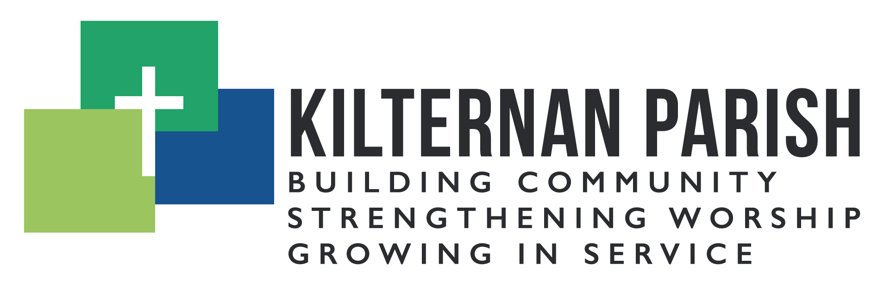
Youth and Young Adult Ministry Co-Ordinator

Background
Kilternan Parish, Church of Ireland, is seeking a Youth and Young Adult Ministry Co-ordinator to join the staff team on a flexible part time basis. The purpose of the role is to develop and support the parish’s work with young people and young adults.
The Youth and Young Adult Ministry Co-ordinator will work closely with the Rector, the Pioneer Minister and the staff team. Kilternan Parish is a faith-based organisation within the Church of Ireland tradition. Applicants do not need to be from that tradition, but they would need to be sympathetic to it, and to the parish’s mission of building community, strengthening worship, and growing in service.
The position is for 20 hours per week and will be administered through Kilternan Parish.
There is the possibility of an additional 10 hours per week whereby the successful applicant will be assigned to work alongside the Dublin Glendalough Youth Council (DGYC) team.
Key Responsibilities within Kilternan Parish
- To strengthen our ministry with teenagers, including but not limited to regular youth groups. We currently have once a month Youth Night on a Friday. There is a long-term appetite to increase this to twice a month and to deepen our discipleship.
- Encourage the participation of young people and young adults in worship. There are opportunities for the successful candidate to lead and teach at the 9:30am worship service.
- To disciple young people so that they can grow in faith and mission. This will include assisting in the annual confirmation programme (usually January – April)
- To identify potential volunteers, encourage and mentor them and help establish them in the ministry to young people
- To support the Rector and Children and Family Ministry coordinator in ministry to the local Primary School, by taking an active role in school assemblies, special events, etc.
- To work with the church team in developing a ministry for young adults. This is an evolving piece of work. There is an ambition to develop a worship and community experience for this underrepresented community.
- To work as part of a team to develop our global citizenship programme. This may include a mission trip to an overseas mission partner.
- To improve means of communication with young people, young adults and parents. This will include contributing to church and community publications
Key responsibilities within DGYC:
- To participate and support in wider DGYC diocesan events where appropriate, e.g. DGYC’s Big Days Out, Winter Madness etc.
- To build up relationships with local secondary schools, and to offer resources and/or support when necessary.
We are looking for someone who:
- Is a spiritually mature Christian with a heart to reach and serve young people.
- Is a team player with a natural ability to relate to young people.
- Is creative, enthusiastic, self-motivated and able to organise themselves and others effectively.
- Has experience of working with young people preferably in a church context.
- Has excellent interpersonal communication skills – written and oral
- Has the ability to work flexibly
- Demonstrates ability to respect matters of confidentiality, sensitivity and compassion
Hours and Renumeration
The role is initially scoped for 20 hours a week (initially a 12-month contract). It can also be offered at 30 hours per week with the addition of 10 hours through DGYC.
Salary 20 hrs (€16,000 pa), 30 hrs (€24,000 pa)
Flexibility of hours will be required for the post-holder, often including evening meetings and regular Sunday involvement.

