Making a difference - Putting the Gospel into Practice

By Ása Björk Ólafsdóttir, Dún Laoghaire

Back in 2013, when I came to Dun Laoghaire, I expected the community to be full of life. I was not mistaken, but soon realised that there was a larger number of people who had fallen on hard times, than I had imagined.

In ministry, one should read/watch over the land, serve those in need, be a shepherd and build bridges. I started talking about the need for a soup kitchen. I was quickly silenced – as being a foreigner, I didn‘t make the connection of social justice/injustice and „soup-kitchens“.

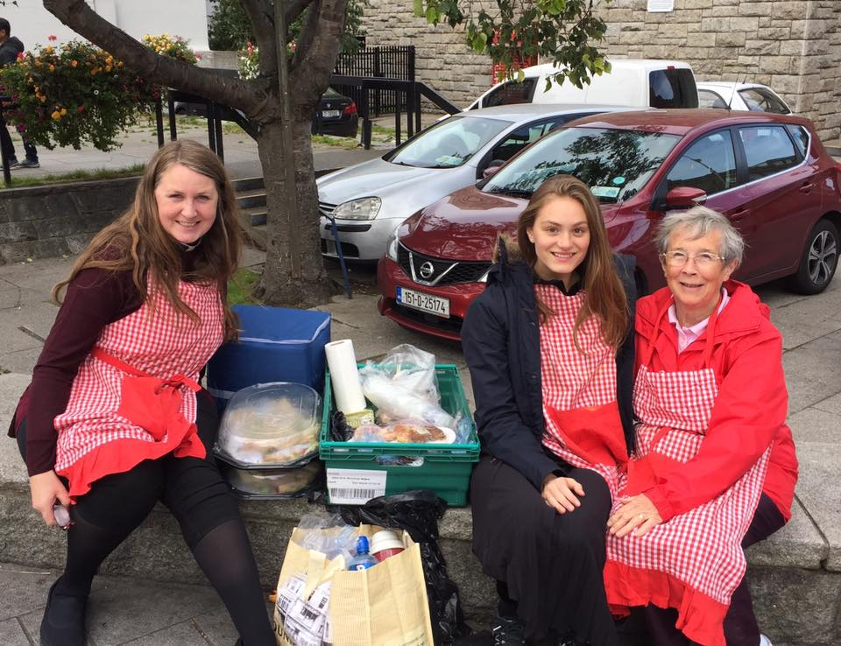

My knees were aching in those days as I found that my prayer/conversation with God was more intense when physically on my knees. A new name “The Dining Room” appeared and from then on it was all go go! To make a long story short, with a group of volunteers from Churches of all denominations and none, we started serving lunches in our Parochial Hall. There was no charge for the meals, but donations welcomed. In fact we were so well supported by local Churches, businesses and individuals as well as shops and wholesellers donating food, that we never once worried about where the funding for the next meals would come from. Three days a week we served 50-70 dinners, volunteers‘ lives were filled with the joy of serving those less fortunate and we saw miracles as lonely and isolated people made friends and some even became our volunteers. One might even wonder if the food was our excause to bring people to us and to one another.

It was always supposed to be an emergency service, but nearly three years later, another charity took over the running of the lunches and The Dining Room‘s role changed. I still buy the Meal-Vouchers and hand them out at the Rectory door, which gives both myself and those in need a platform to talk about whatever is going on in their lives or in the community. The rough-sleepers often tell me about people in need and that way I can drive past a certain location at night to bring someone a sleepingbag a.s.o.

The role of The Dining Room has changed, but is still about restoring dignity and helping people in their need. Sleepingbags and food is the obvious way to help, but during Advent we also receive many Hampers of food and add meat, fresh fruit and vegetables and bring to those in need. Last Advent we had two boxes at the back of Church (they were emptied regularly), one for non-perishable food and the other for presents. I can not begin to tell you the joy the presents brought to people of all ages! We are also willing to look into different situations, such as a single mother-to-be in difficulty or something else. In saying that, social media plays a big part as it is often enough for me to ask for help for someone – and good offers come flooding. The Irish people have a very generous nature and I am constantly and pleasantly surprised.

The aim is always for dignity to be restored – what more could one ask for?

